IAM User Lifecycle Management using Microsoft Entra ID (Azure AD)
1. Introduction
Identity and Access Management (IAM) is a critical component of cybersecurity that ensures the right individuals have appropriate access to organizational resources. It helps manage user identities, authentication, and authorization while maintaining security and compliance.
This project demonstrates the implementation of IAM user lifecycle management using Microsoft Entra ID, focusing on Joiner, Mover, and Leaver processes.
2. Objective
The objective of this project is to simulate real-world IAM operations by:
- Creating and managing user identities
- Assigning role-based access
- Enforcing Multi-Factor Authentication (MFA)
- Performing user lifecycle operations (Joiner, Mover, Leaver)
- Validating access control through testing
- Reviewing logs for audit and compliance

3. Tools & Technologies Used
- Microsoft Entra ID (Azure Active Directory)
- Microsoft Azure Portal
- Microsoft Graph PowerShell
- MyApps Portal
- Microsoft Authenticator (MFA)

4. Architecture Overview
This project simulates an organization with:
- IAM Administrator (Admin Account)
- Users (Jane – HR, Chris – Finance)
- Applications (HR App, Finance App)
- Authentication Layer (MFA)
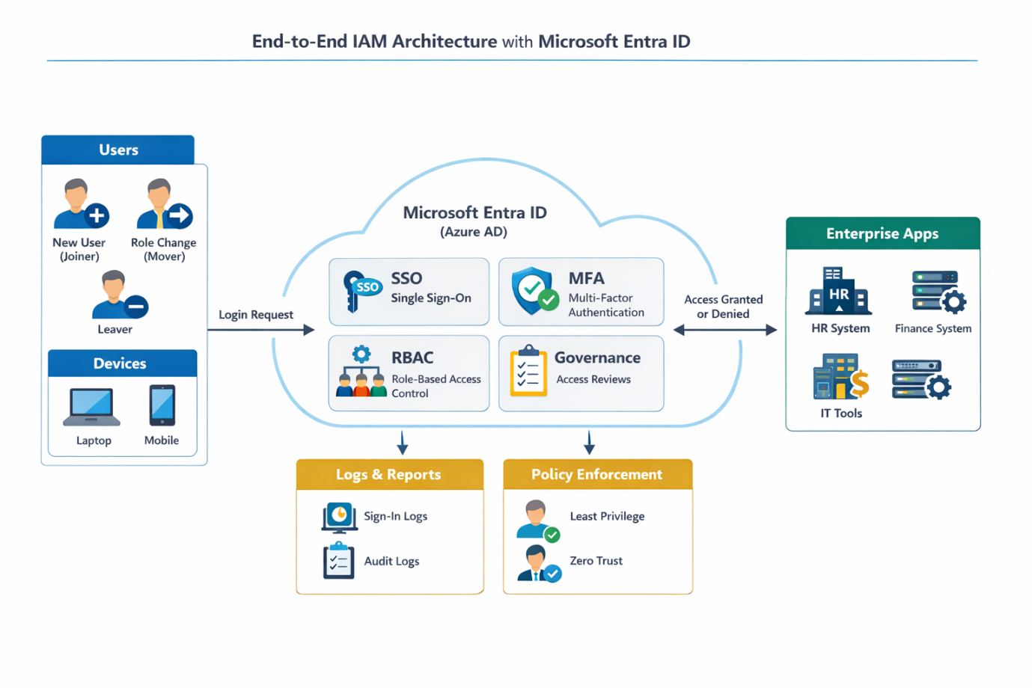
IAM Architecture Diagram with Microsoft Entra ID

5. Environment Setup
The environment was prepared using Microsoft Entra ID.
Steps performed:
- Created Azure account and accessed Azure Portal
- Navigated to Microsoft Entra ID
- Verified tenant configuration
- Enabled Security Defaults to enforce MFA
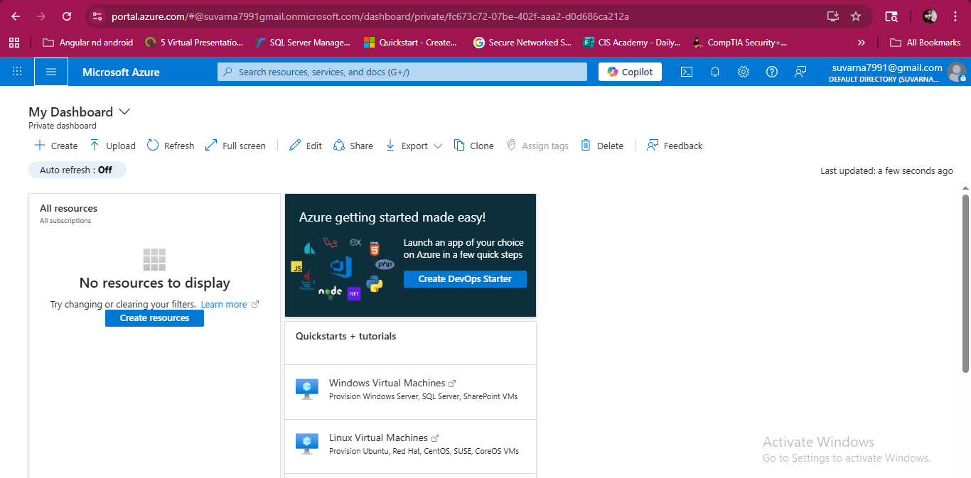
Azure Portal Dashboard
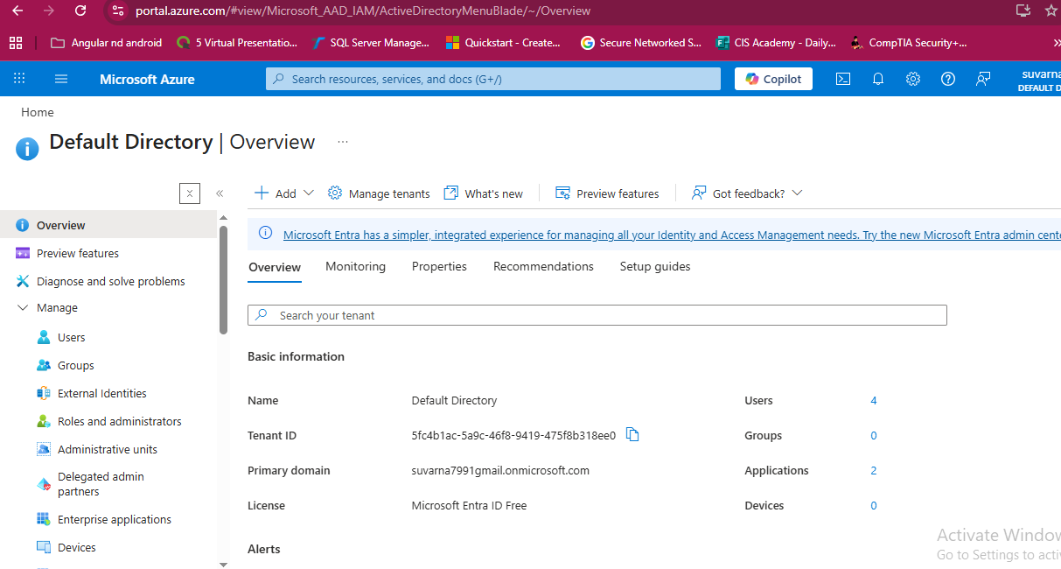
Entra ID Overview
6. User Creation (Joiner Process)
Users were created to simulate employee onboarding.

Users Created:
- Jane Smith (HR Department)
- Chris Johnson (Finance Department)

Steps Performed:
- Navigated to Users section in Entra ID
- Created new users manually and via PowerShell
- Assigned temporary passwords
- Enforced password change at first login
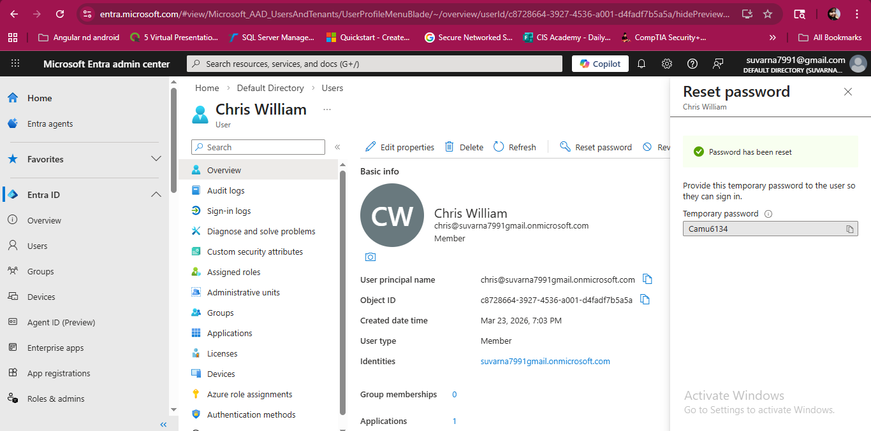
User Creation Overview Page
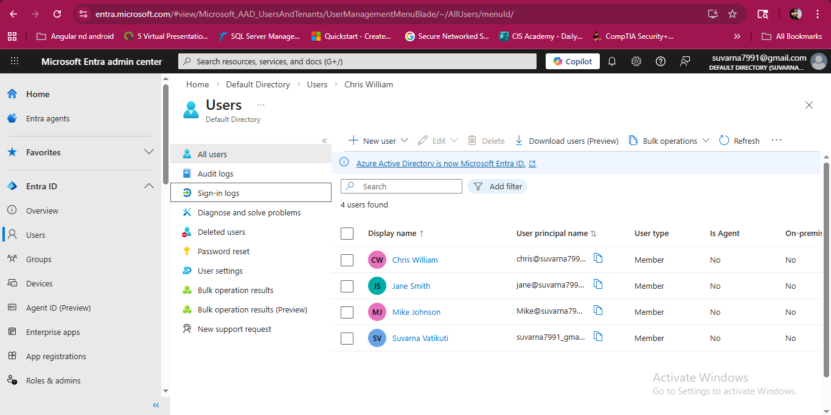
Users Creation List
7. Application Setup
Enterprise applications were created to simulate business systems.

Applications Created:
- HR App
- Finance App
- IT Tool App
- SSO-Test App

Steps Performed:
- Navigated to Enterprise Applications
- Selected “Create your own application”
- Configured application name and integration type
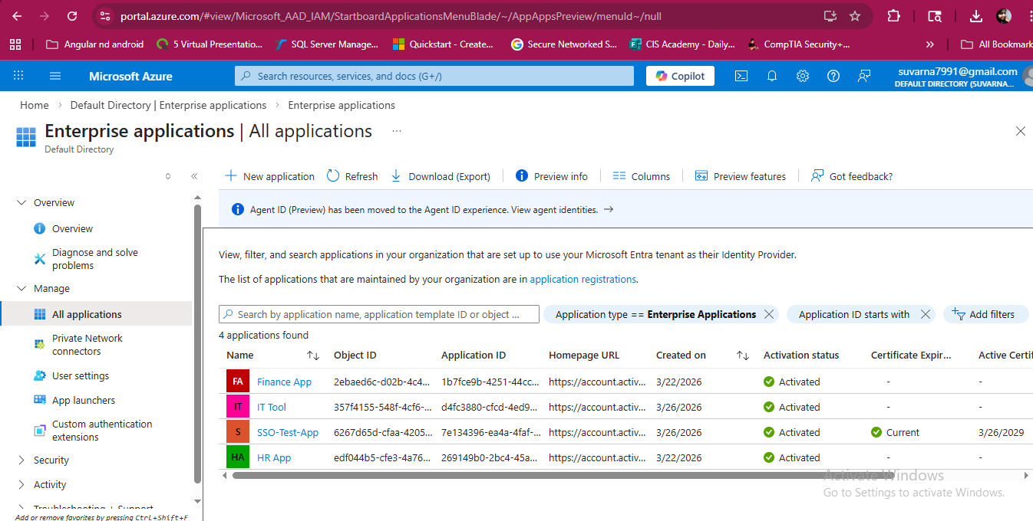
Enterprise Applications List
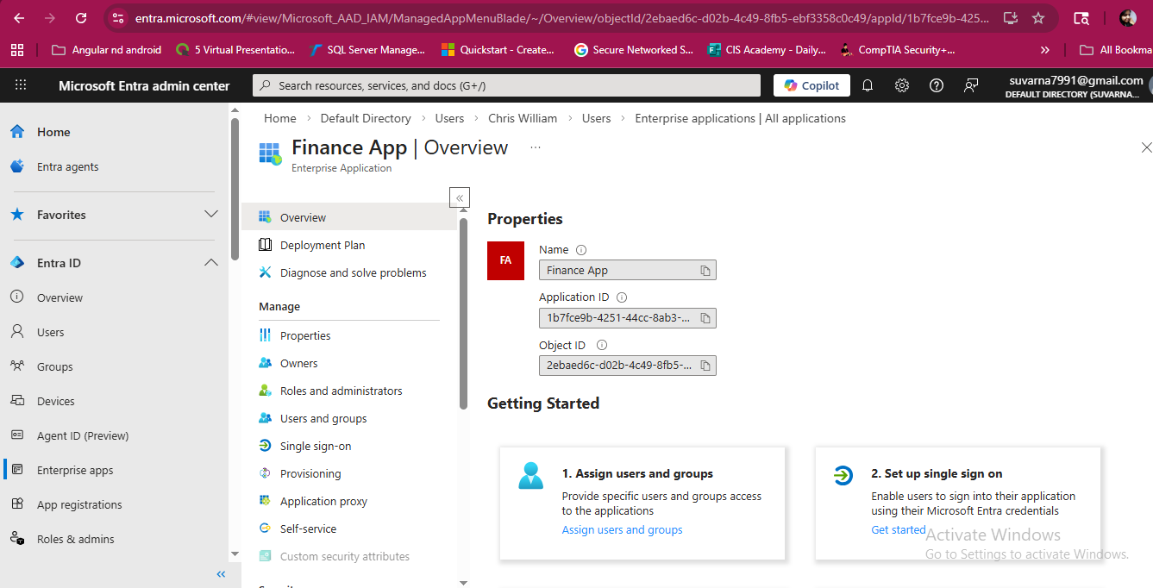
Enterprise Application Creation

8. Access Assignment (Least Privilege Principle)
Access was assigned based on job roles following the principle of least privilege.

Key Concept:
Users were granted only the minimum access required for their role, ensuring no excessive permissions were assigned.
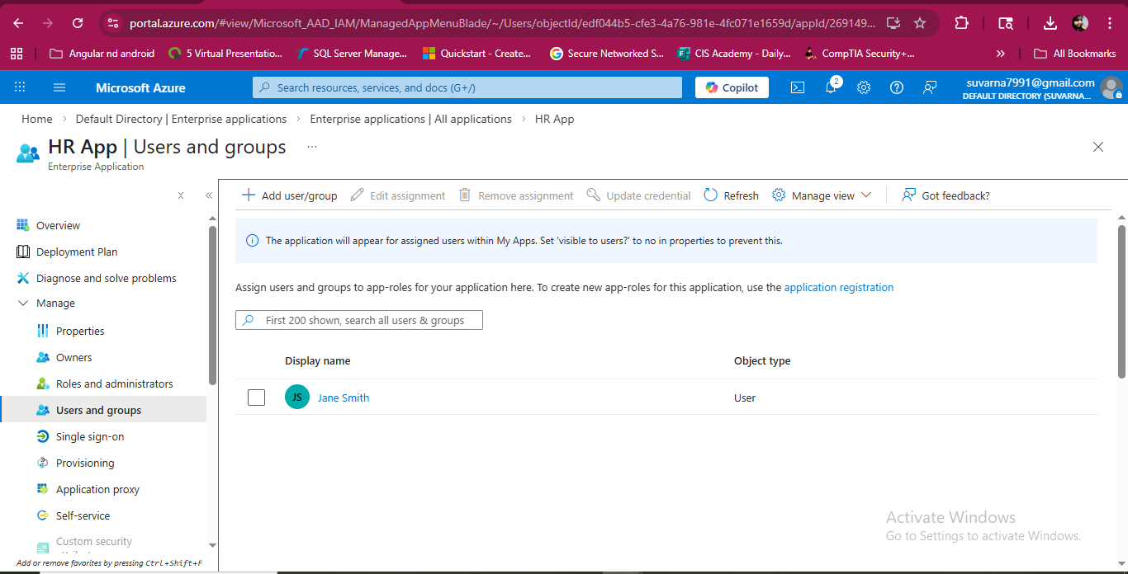
HR App Assignment
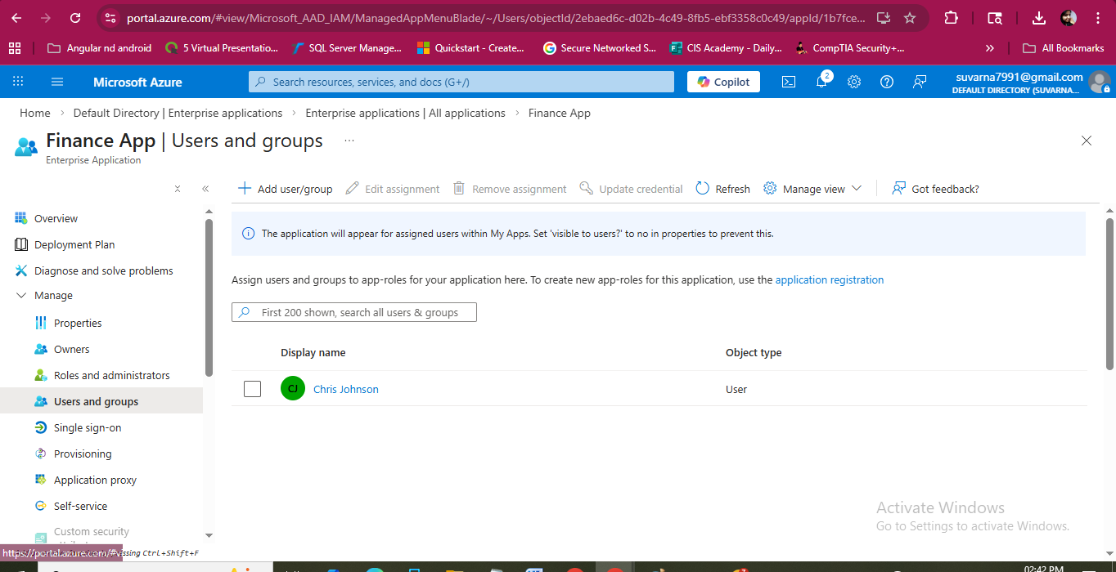
Finance App Assignment

9. Multi-Factor Authentication (MFA) Setup
MFA was enforced using Security Defaults.

Steps Performed:
- User logged in for the first time
- Prompted to configure Microsoft Authenticator
- Completed MFA registration

Outcome:
- Strong authentication enforced
- Improved account security
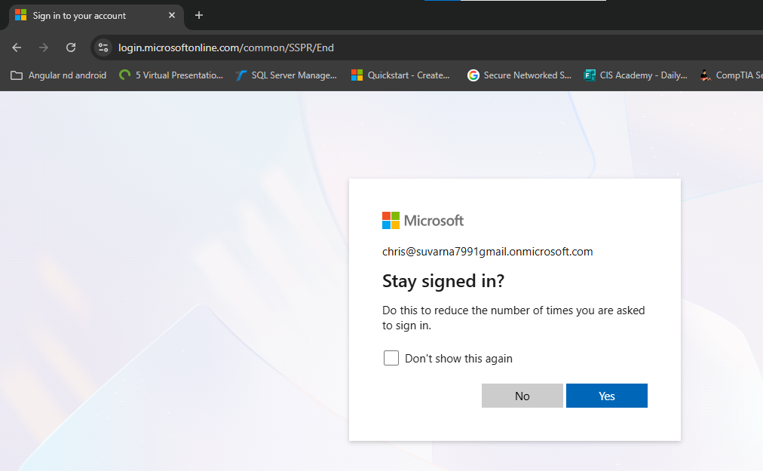
MFA Setup of User(Chris) Login Successful
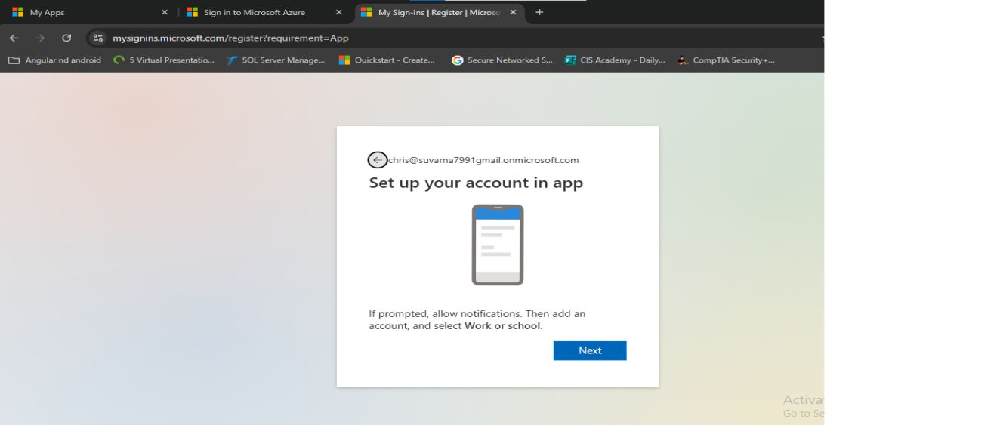
MFA Authenticator Setup

10. Access Testing
User access was validated through the MyApps portal.

Results:

Jane:
- Access to HR App ✔
- No access to Finance App ❌

Chris:
- Access to Finance App ✔
- No access to HR App ❌

Observation:
Users did not have administrative privileges and could only access assigned applications.
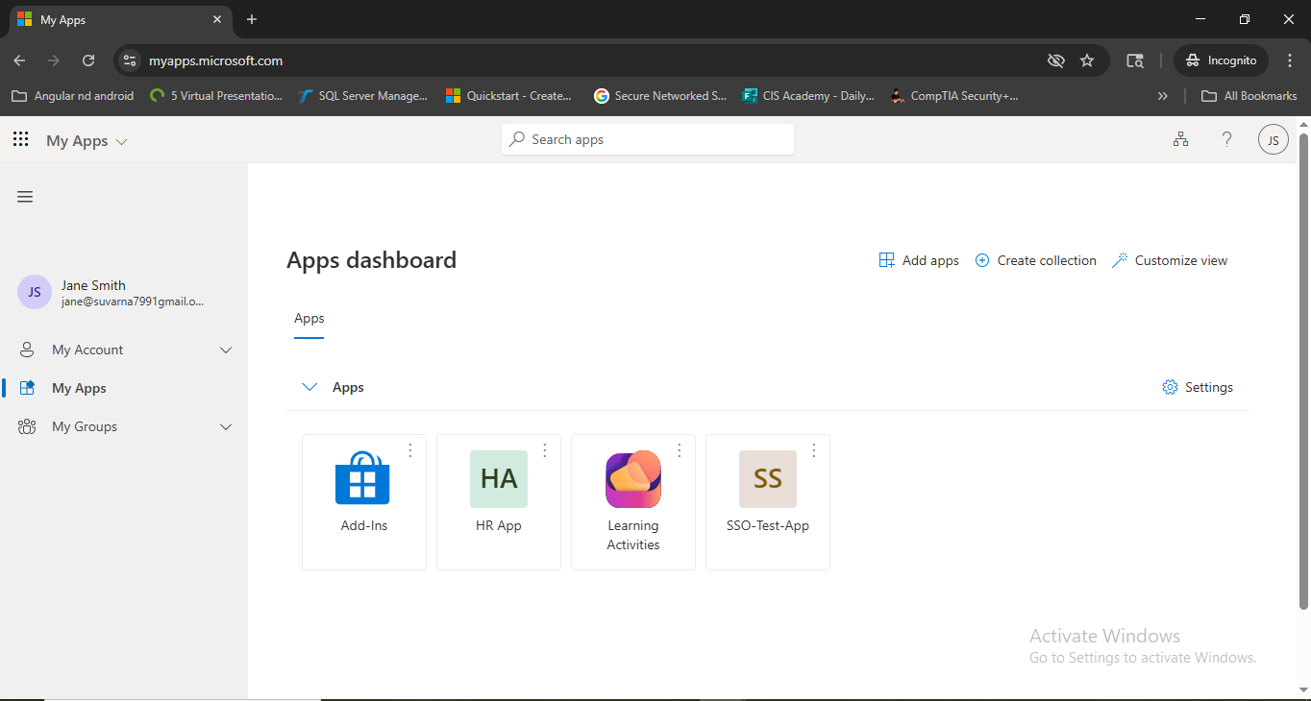
My Apps Jane
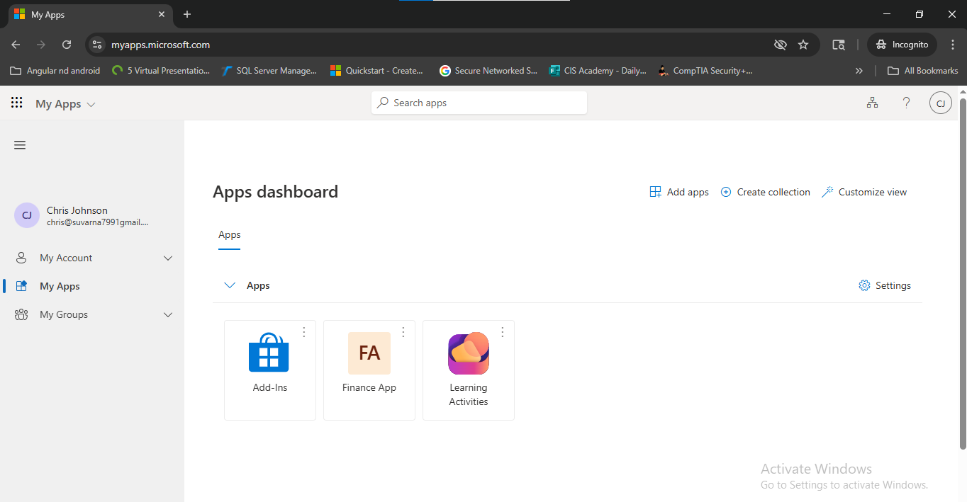

My Apps Chris

11. Mover Scenario (Role Change)
A role change scenario was simulated.

Scenario:
Jane moved from HR to Finance department.

Steps Performed:
- Removed Jane from HR App
- Assigned Jane to Finance App

Result:
- Previous access revoked
- New access granted successfully
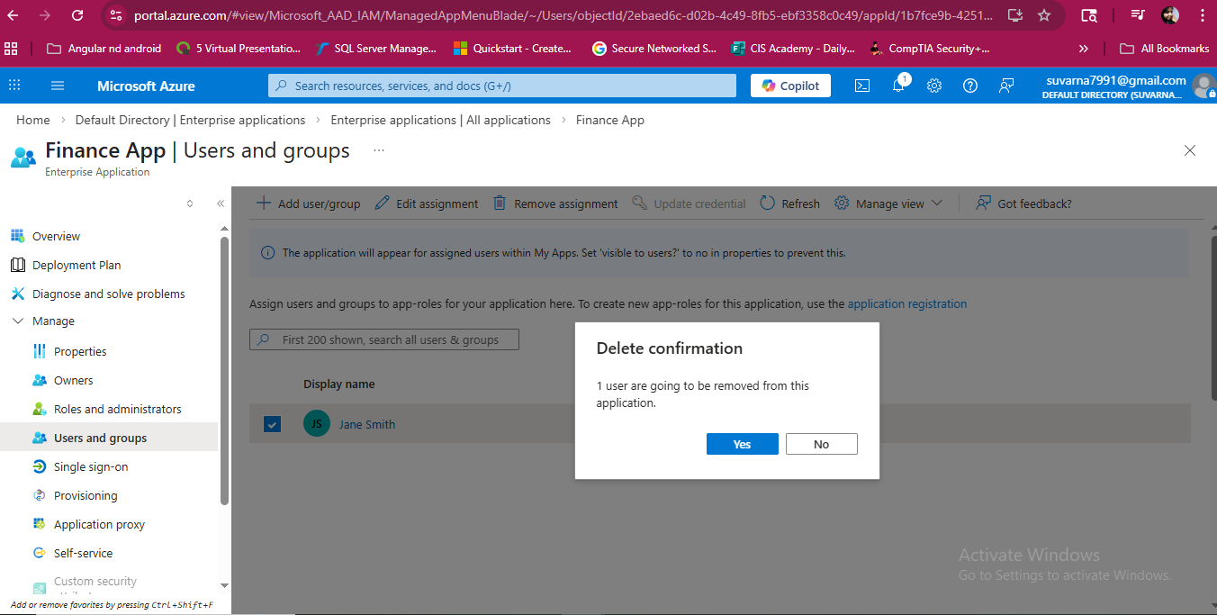
Application assignment revoked for user Jane
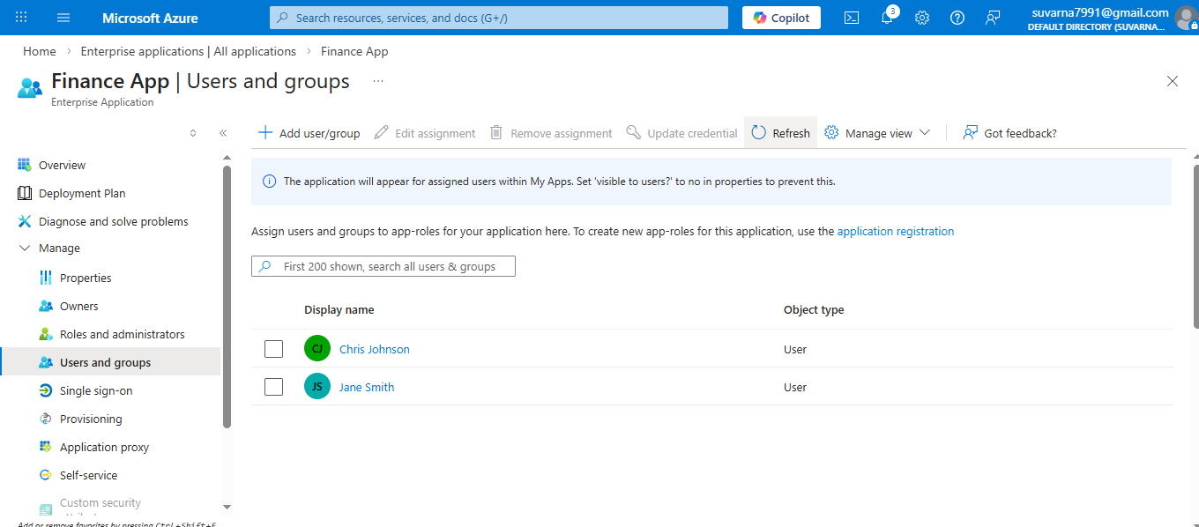
Application assignment changed for User Jane

12. Leaver Scenario (User Offboarding)
User offboarding was implemented to simulate employee exit.

Scenario:
Chris leaves the organization.

Steps Performed:
- Blocked user sign-in
- Removed application access
- Revoked active sessions

Result:
- User login was blocked
- All access was successfully removed
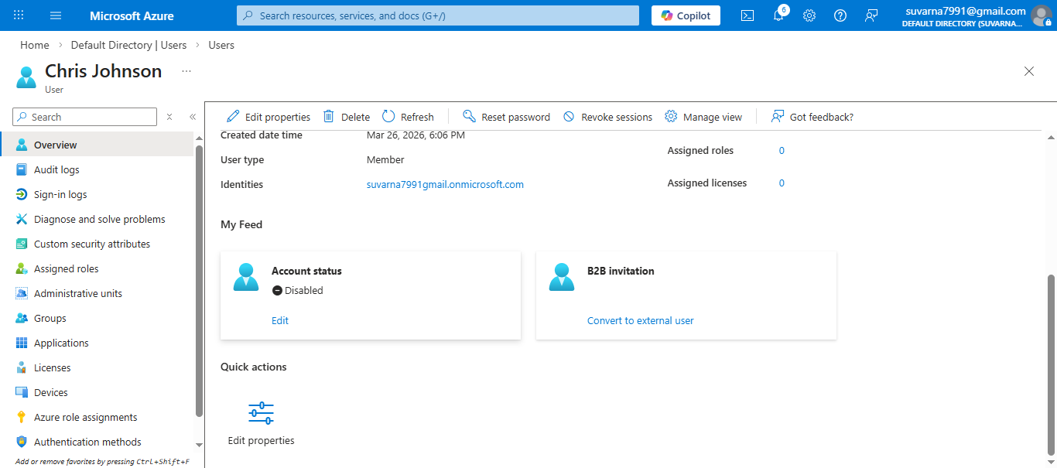
User account blocked from Sign-in as Account status is DISABLED
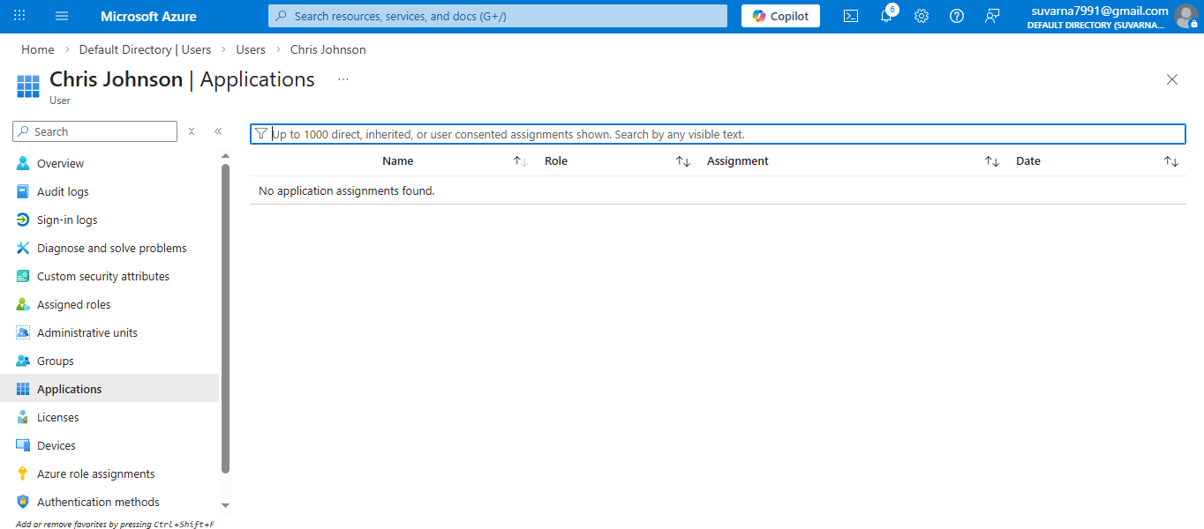Application access removed and revoked sessions

13. Audit Logs and Monitoring
System logs were reviewed to validate IAM activities.

Logs Reviewed:
- User creation events
- Application assignments
- Sign-in attempts
- Account lockouts

Importance:
Audit logs ensure transparency, compliance, and traceability of actions.
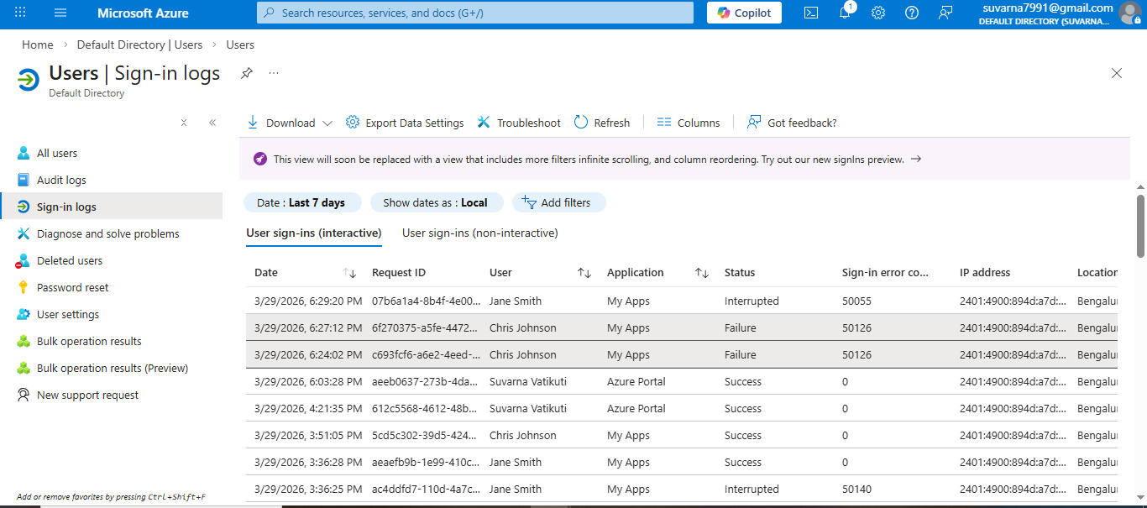
Sign-in Logs

15. Key Learnings
- Understanding IAM lifecycle (Joiner, Mover, Leaver)
- Implementation of least privilege access
- Importance of MFA in identity security
- Hands-on experience with Microsoft Entra ID
- Troubleshooting real-world IAM issues

16. Conclusion
This project successfully demonstrates end-to-end IAM lifecycle management using Microsoft Entra ID. It highlights how organizations can securely manage user identities, enforce access control, and maintain compliance through structured onboarding, role transitions, and offboarding processes.
The implementation of MFA and automation enhances both security and operational efficiency.

17. Future Enhancements
- Implement group-based RBAC
- Configure Conditional Access policies
- Integrate IAM with HR systems
- Enhance automation workflows

